Christmas Lights

Hexham Town Council do not quail at the sight of a storm! Despite the arrival of Storm Arwen they still turned out to turn on the Christmas lights. Although the weather was very blowy a large crowd came to see the lights being turned on. Santa did a fine job of turning on all the lights in the park and on the Christmas Tree.

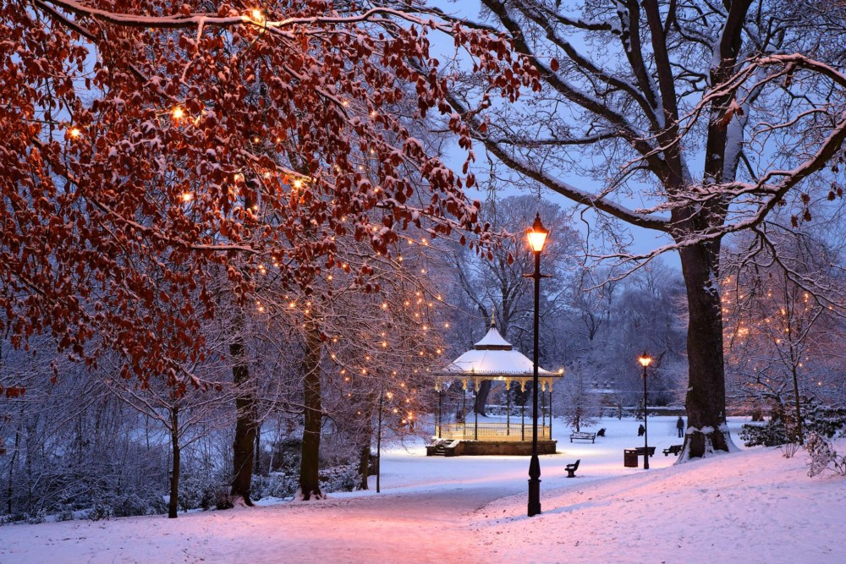

New festoons have been added to the park lights (not shown in the above picture).

