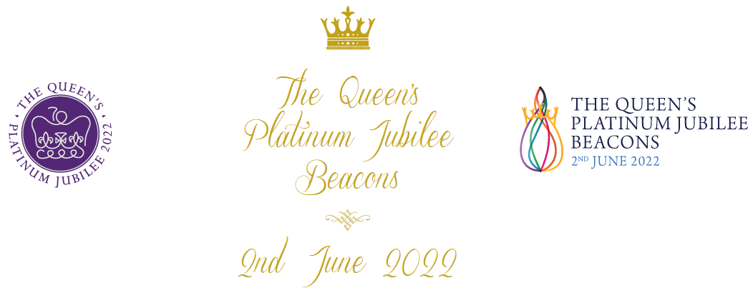

NEWS RELEASE
We are proud to be part of the Queen’s Platinum Jubilee Beacons and Associated
Activities on June 2, 2022.

Hexham Town Council is playing its part in the Queen’s Platinum Jubilee Beacons and Associated Activities, in the first special event celebrating Her Majesty, The Queen’s 70th year as our Monarch.

Organised by Bruno Peek LVO OBE OPR, Pageantmaster, the event will see thousands of town criers, Pearly Kings and Queens, pipers, buglers and choirs performing, ahead of the lighting of more than 2,022 beacons throughout the United Kingdom, Channel Islands, Isle of Man, UK Overseas Territories and within the Commonwealth countries at 9.45pm on Thursday June 2, 2022. Beacons across Hadrian’s Wall will be lit at the later time of 10.00pm.

Schedule:
• 2.00pm: Hundreds of town criers and 50 Pearly Kings and Queens announce a specially written
proclamation heralding the lighting of the beacons later that day.

• 9.35pm: Traditional pipers, including Northumbrian pipers and pipe bands will play Diu Regnare, a unique tune specially written for the occasion by Piper Major, Stuart Liddell, the world’s leading piper.
• 9.40pm: Buglers will officially announce the lighting of the beacons with a specially written bugle call, entitled Majesty.
• 9.45pm: Community choirs across all nations will sing the song called A Life Lived with Grace, which has been written and composed by Lucy Keily, from Australia, and Vincent Atueyi Chinemelu, from Nigeria. Beacons lit across the rest of the UK.
• 10.00pm Beacons will be lit across the communities of Hadrian’s Wall - Including Hexham
Bruno Peek LVO OBE OPR, Pageantmaster of The Queen’s Platinum Jubilee Beacons, said:
“Building on a long tradition of lighting beacons to mark significant royal celebrations, more than 2,022 Jubilee Beacons will be lit across the United Kingdom, Channel Islands, Isle of Man, UK Overseas Territories and within the Commonwealth countries on the first evening of the four-day Jubilee Weekend (on Thursday June 2, 2022). The Beacons will enable local communities to join together and pay tribute to Her Majesty as part of the official programme of events.

For the first time, town criers, pipers, buglers and choirs from the UK and the Commonwealth will come together to join in the celebrations in their own individual and special way. It is wonderful to see the range of support for beacon lighting, which will highlight both the diversity and the unity of the nation and the Commonwealth. The Queen has lit up our lives for 70 years through her dedicated service and commitment. We would like to light up the nation and the Commonwealth in her honour.”

Our Participation

Hexham Town Council is taking part in the following:

Activity: Town Crier crying the Royal Proclamation
Location: Hexham Marketplace
Time: 2pm

Activity: Town Crier announcing the start of the ceilidh
Location: Hexham Marketplace
Time: 8.29pm

Activity: Jubilee Ceilidh with Hexham Village Band
Location: Hexham Marketplace
Time: 8.30pm

Activity: Piper, piping Diu Regnare
Location: Hexham Marketplace
Time: 9.35pm

Activity: Bugle Call
Location: Hexham Marketplace
Time: 9.40pm

Activity: Singer
Location: Hexham Marketplace
Time: 9.45pm

Activity: Town Crier announcing the lighting of the Beacon
Location: Hexham Marketplace
Time: 9.59pm

Activity: Lighting of the Beacon
Location: From the top of The Moot Hall
Time: 10pm

Contact Name:
Contact Email:
Contact Tel No:

Jane, Lady Gibson, Chair, Hadrian’s Wall WHS Partnership Board, said:
“Communities along the length of Hadrian’s Wall are taking part in this unique celebration of the Queen’s Platinum Jubilee made even more significant to us as it falls in the same year as our Hadrian 1900 festival, commemorating Hadrian arriving in northern Britain to supervise the building of his Wall in AD122”.

The Queen’s Platinum Jubilee Beacons and Associated Activities has been conceived and organised by Pageantmaster Bruno Peek, and his dedicated team.

ENDS

